

**T.Y.B.TechComputerScience&Engg.,Semester:V,A.Y.:2023–2024 Course Name: Machine Learning (Theory), Course Code: UCSC0502**

**ISE 2, Component 1: Problem Solving Part 2**

**Instructions:**

* Students must maintain a *Separate Notebook* to write the assignments.
* Attempt all questions, complete the assignment in written form, and get it signed by your course teacher.
* The assignment checking will take place during the lab sessions.

1. Apply the K-means clustering for following data with K=2. State difference between K-means clustering and hierarchical clustering.

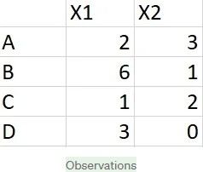

1. Draw a dendrogram for the following proximity matrix and find the number of clusters that we get.

|  |  |  |  |  |  |
| --- | --- | --- | --- | --- | --- |
|  | 1 | 2 | 3 | 4 | 5 |
| 1 | 0 |  |  |  |  |
| 2 | 9 | 0 |  |  |  |
| 3 | 3 | 7 | 0 |  |  |
| 4 | 6 | 5 | 9 | 0 |  |
| 5 | 11 | 10 | 2 | 8 | 0 |